Created an application using Elastic beanstalk

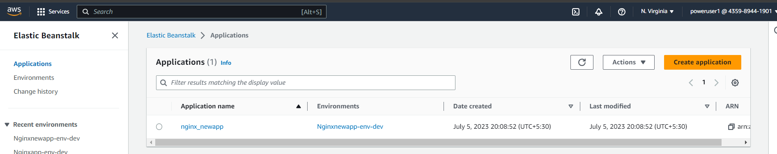

Code commit repo:

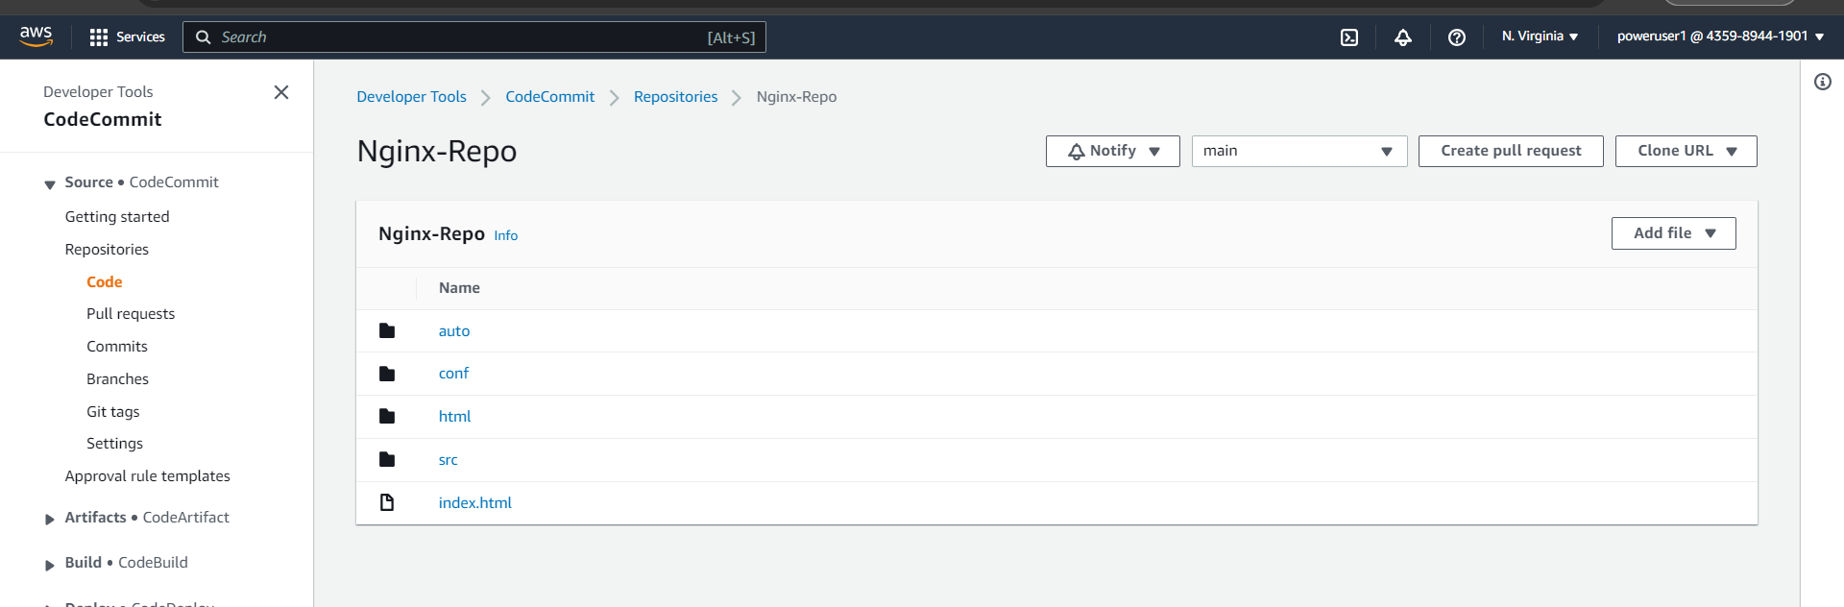

CodePipeline

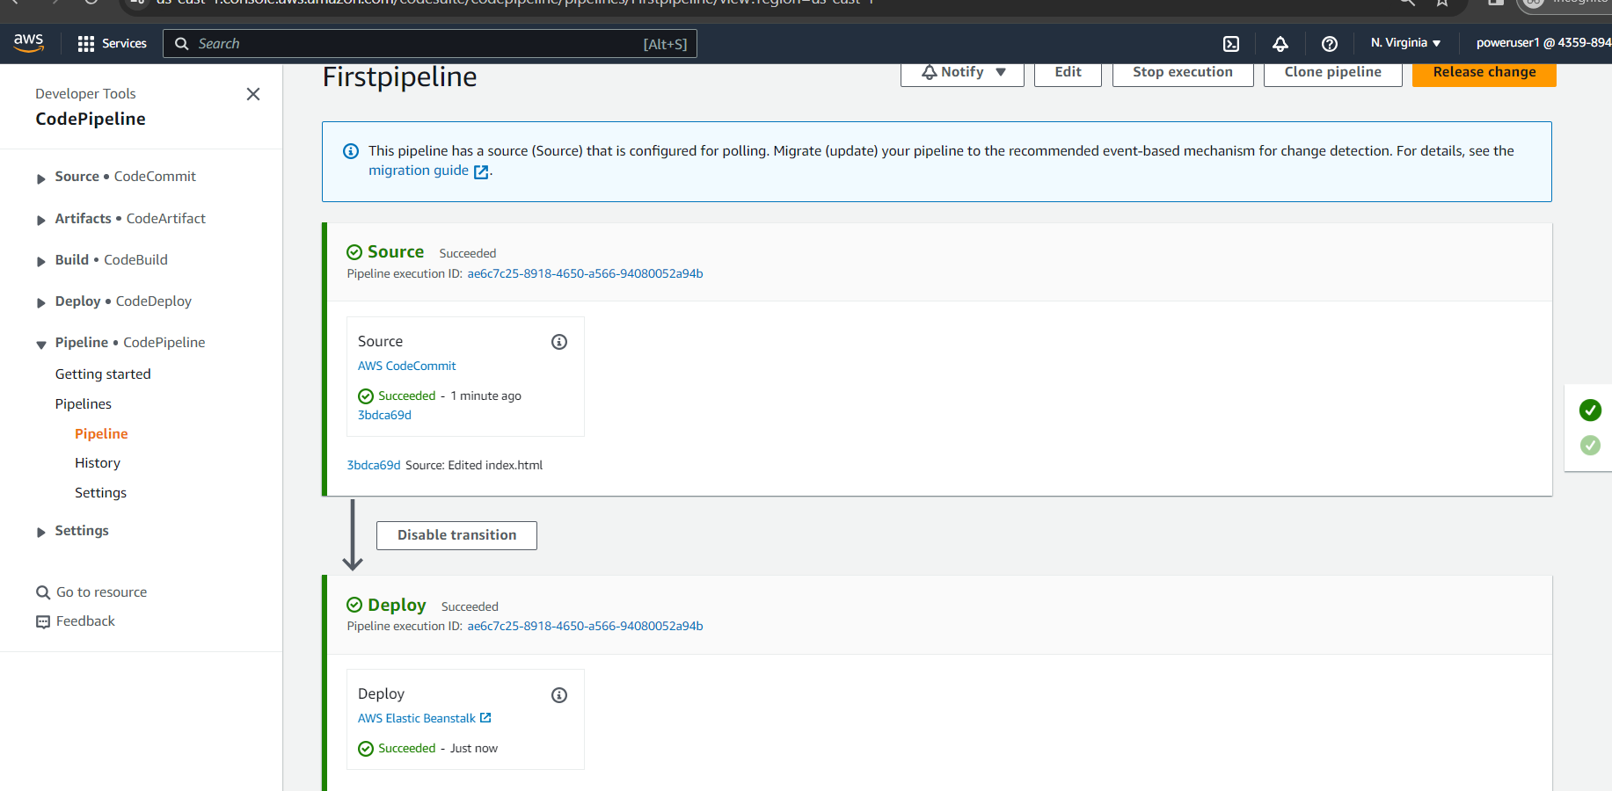

Output:

